April 13, 2026
nocturnals
Miguel cuon, Damon Corso, Michael dodd
Dreamscape System Requirements Document
DRAFT
Table of Contents
Introduction 1
Description Model 1
Class Diagram 1
Use Case Diagram 1
Use Case Scenarios 1
System Sequence Charts 1

Introduction
This document is dedicated to describing and visualizing the different requirements, functions, classes, and systems that are used in Dreamscape. This document gives an in-depth text summary using a description model. Additionally, it provides a visualization of classes used within Dreamscape’s code, including system objects, attributes, and methods. A use case diagram, a visual for all use cases that are available to the user. The use case scenarios provide a detailed description of the use cases visualized in the previously stated diagram, indicating pre-conditions, post-conditions, triggers, and steps. The system sequence chart provides a visual for any systems present within Dreamscape, the users and their interactions with different classes using methods.

Description Model
The Home Screen will consist of the 5 following functions below:
The alarm function will be created, set, unset, or deleted for when the user wants their alarms to be. This includes its settings as well.
The meditation tip function will be auto created by the app for when you snooze your alarm. This will include creating and delete methods.
The routine function will also be auto created by the app after accumulating what your sleeping habits are, making them your own generated routines. Methods include create, get, set, settings, and delete
The music function will be music from the app or linked from a third party to play when they are sleeping, napping, meditating, or dozing off. These methods include, play, pause, select, stop, skip, and previous.
The watch/device link compatibility function will be the option for the user to link their outside devices to this app. This includes link, unlink, get, set, pair, and unpair.
These are the app’s requirements according to the Output, Input, Processes, Performance and
Security.
OUTPUT REQUIREMENTS
This apps output requirements are:
- There must be audio emitting out the mobile device, even when device is off
- Must display a UI to ‘snooze’ an alarm
- Displays a meditation tip after snoozing alarm
- Allow routines to be created automatically or manually
INPUT REQUIREMENTS
- User must have an account
- User must have sleep data
- Alarms must be set for an output
- Must have permissions to allow user to link devices to app
- Must allow permissions to allow audio outside app
PROCESS REQUIREMENTS
- Authenticate membership and account details
- Transfer playlists between platforms using account data matching
- Synchronize routines and alarms, updated used and unused alarms and routines
- Save and remove alarms, routines and playlists from the user’s menu
- Store user data, third-party music data, meditation bookmarks, and playlists
- Handle exceptions, such as bad transfers with third-party data, duplicate alarms, restricted permissions, and missing sleep data
PERFORMANCE REQUIREMENTS
- Third-party music accounts and linking watch to app should complete within 30-45 seconds
- API requests to third-party music platforms should respond within their own limits (should take about 2 seconds)
- The system should maintain acceptable performance for more than 150+ alarms in the app, 200+ bookmarks in meditation articles, 150+ playlists, and 20+ routines without issue
- Meditation tips are to occur strictly after the user has turn off their alarms
- There should be no loss inn performance when linking an external smart device to the application
SECURITY REQUIREMENTS
- Allow 2-step verification to allow maximum security when logging in to their account
- User password will be encrypted when typed in to the password bar
- Data access must proceed with the principle of least privilege, to ensure that the users can modify their data and sleep data
- Users cannot add playlists that are private in their third-party platform

Class Diagram
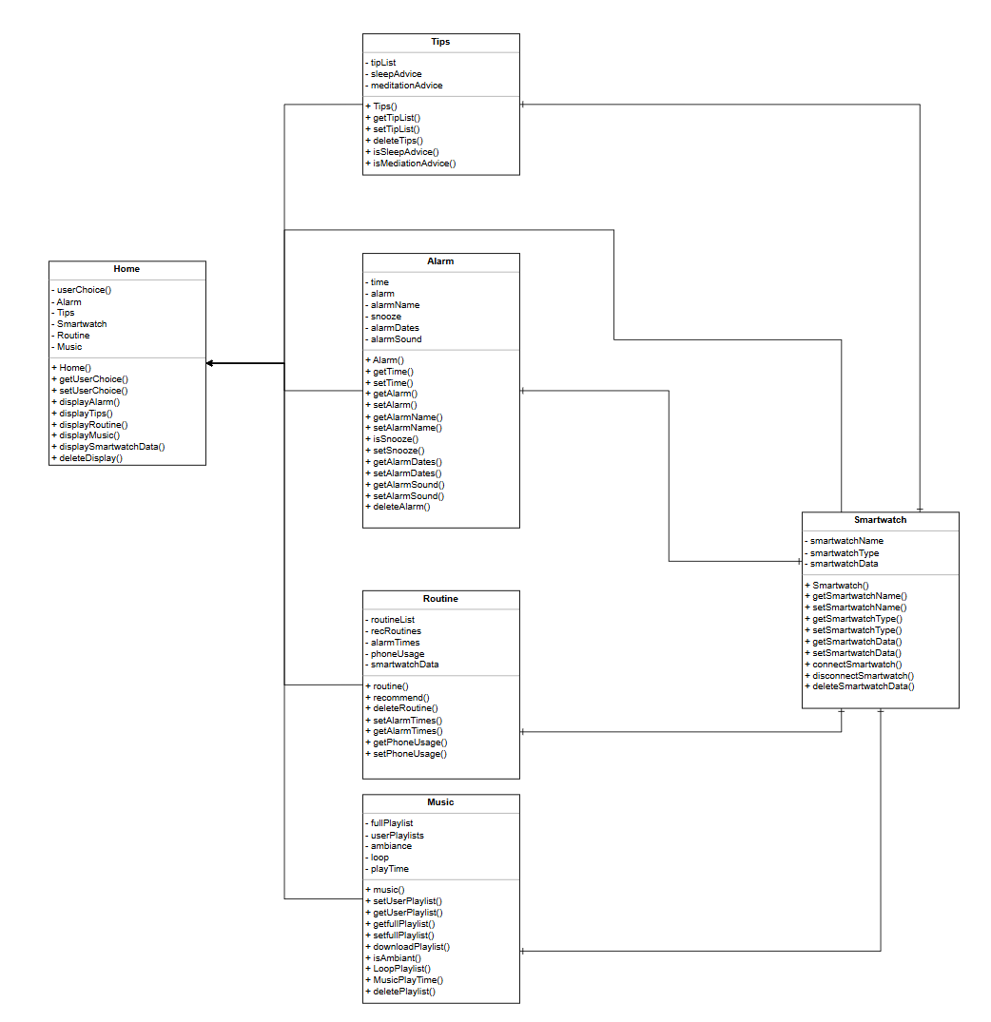

Use Case Diagram
Create a Use Case Diagram for all of the "uses" of your system. This diagram may be included as a separate file – it does not need to be inserted into this Word document.

Use Case Scenarios
Create a full description Use Case Scenario (detailed descriptions) for each use case of the system. This full scenario should include an enumerated list of steps involved in the activity as well as any exception conditions.

System Sequence Charts
For each Use Case Scenario, provide a sequence diagram. Use your class diagram, use case diagram and scenarios to create the corresponding System Sequence Diagram.

